**Introduction to Power BI**

Microsoft Power BI is an interactive data visualization software product developed by Microsoft with a primary focus on business intelligence. Power BI is a collection of software services, apps, and connectors that work together to turn various sources of data into static and interactive data visualizations. Data may be input by reading directly from a database, webpage, PDF, or structured files such as spreadsheets, CSV, JSON, XLSX, and SharePoint.

* CSV Files: CSV files are often used when data needs to be compatible with many different programs. CSVs can be opened in text editors, spreadsheet programs like Excel, or other specialized applications. A Comma Separated Values file is a plain text file that contains a list of data.
* JSON: A JSON file is a file that stores simple data structures and objects in JavaScript Open Notation format, which is a standard data interchange format. It is primarily used for transmitting data between a web application and a server. JSON files are lightweight, text-based, human-readable, and can be edited using a text editor.
* XLSX: XLSX files are files used in Microsoft Excel, a spreadsheet application that uses tables to organize, analyse, and store data. Each cell can contain text or numerical data, including incorporating mathematical formulas.

**How to Install and Open a Dataset in Power BI:**

Search for MS Power BI on your search Engine and visit the [www.microsoft.com](http://www.microsoft.com) and install the desktop application.

Launch your POWER BI application and click on blank report to create a new report.

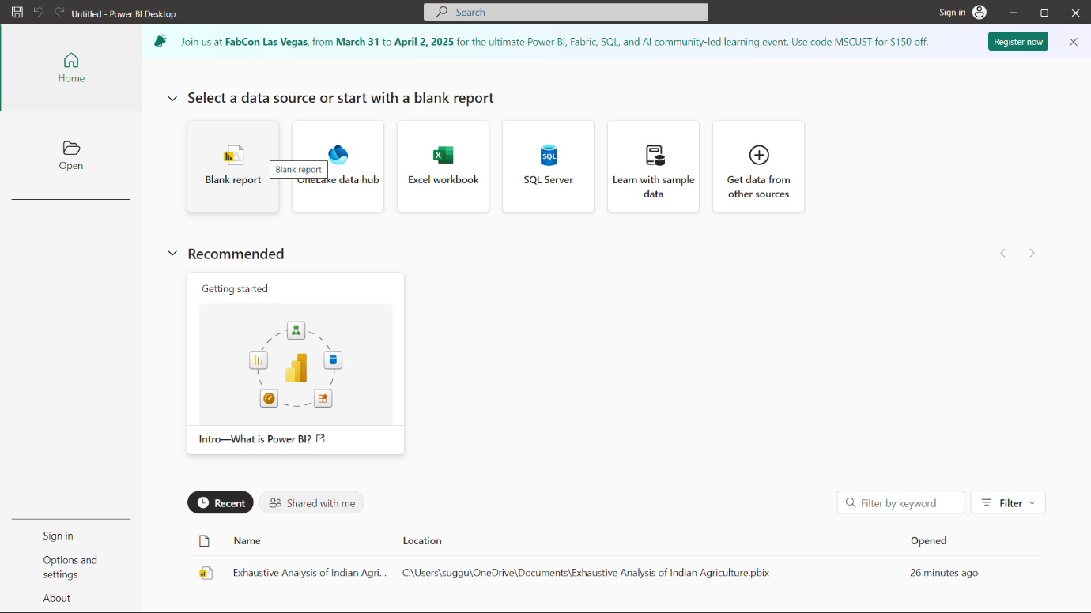

Now click on import data from Excel in order to upload the dataset in your device.

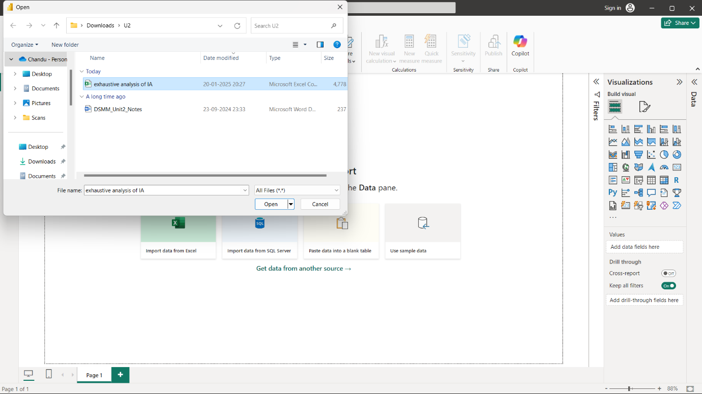

Select the required file and import the dataset. Now you’ll encounter 3 options

* Load: Load will import data directly.
* Transform: Transform will help you to process data.
* Cancel: This option will deselect the file and prevent import

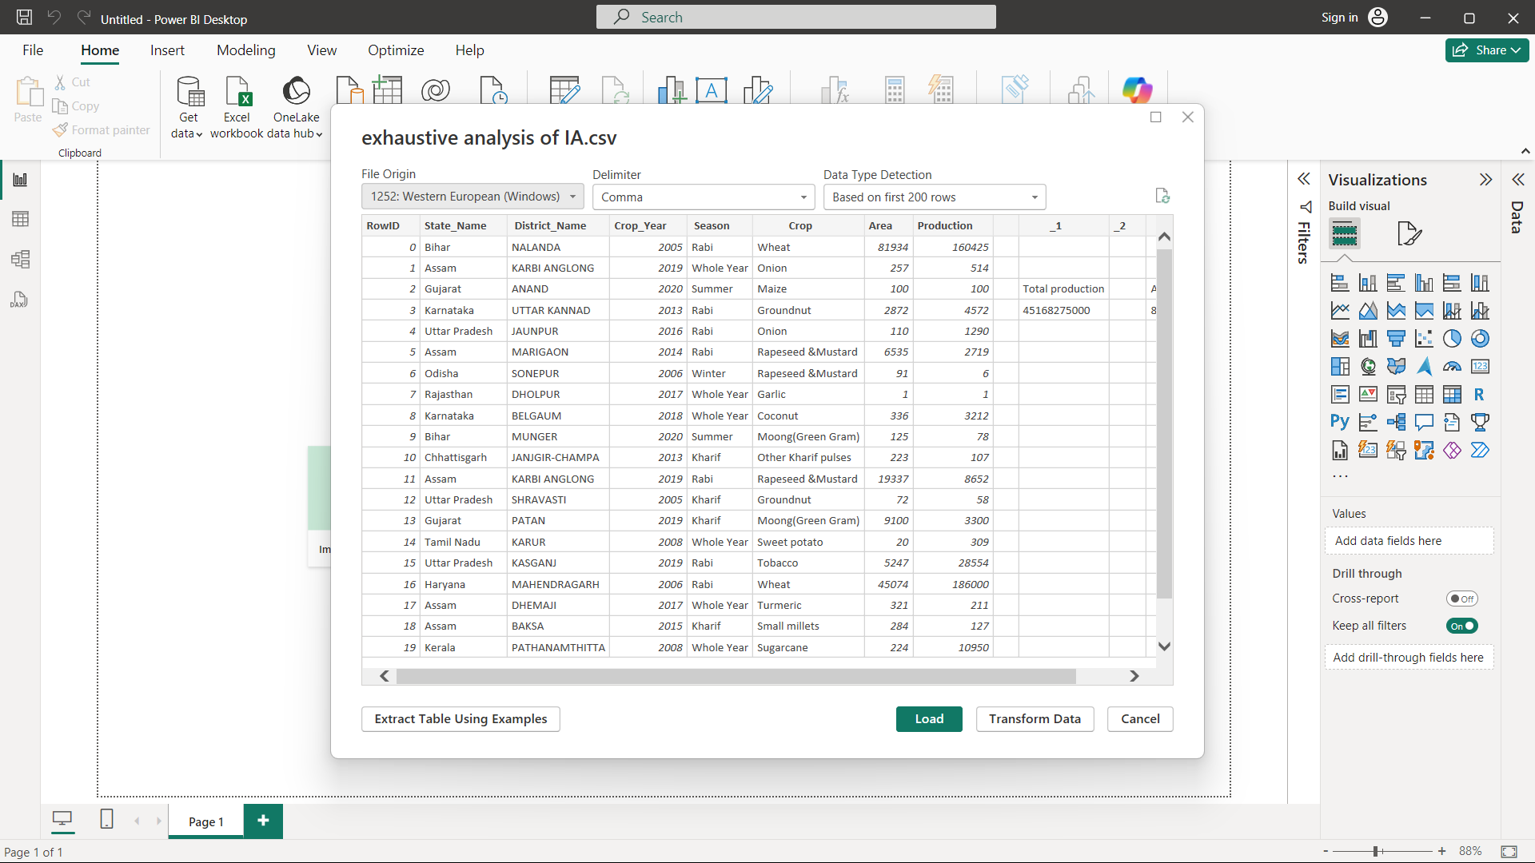

For the time being we are importing without and preprocessing just for explanation. Now we will click on the transform data icon on the taskbar.

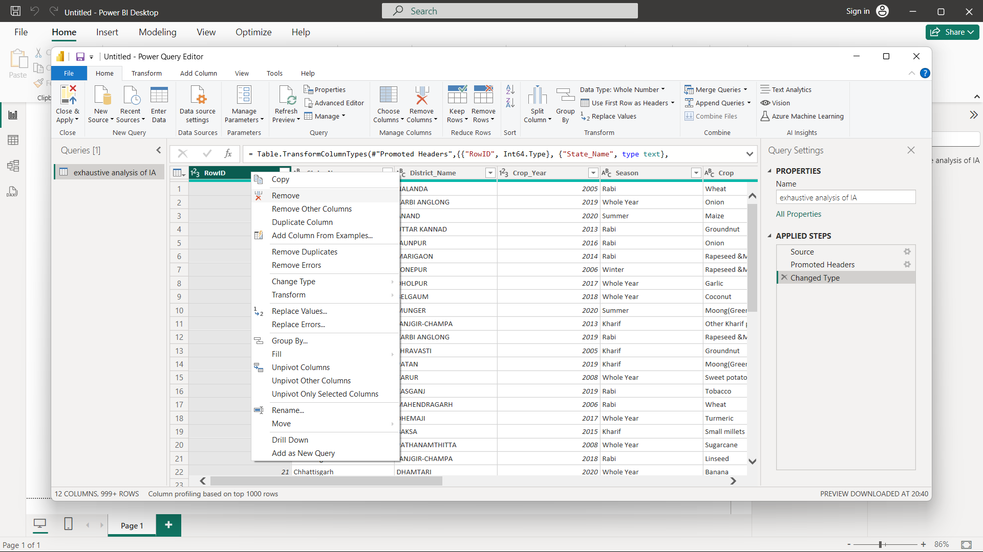

This opens the Power Query Editor, where we can edit our files accordingly.

Here, we are trying to delete the RowID column (for example). Select the column, upon right click and then click on remove icon.

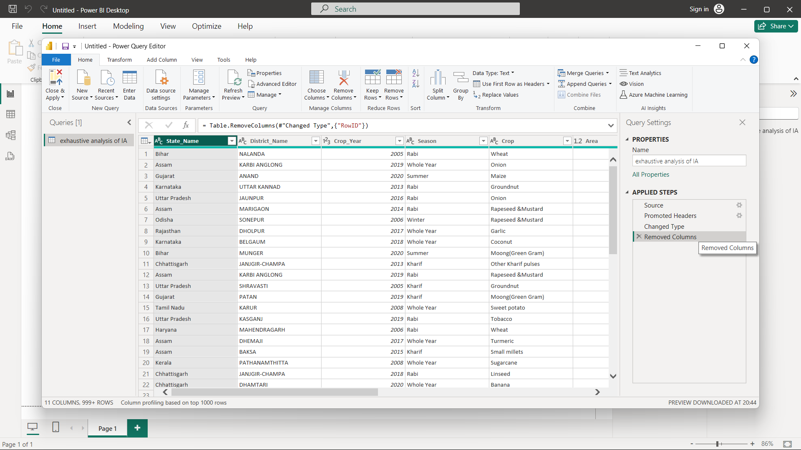

Now the resultant file is displayed after the removal of that column. Now, in the Applied Steps section another column is being added namely Removed Columns.

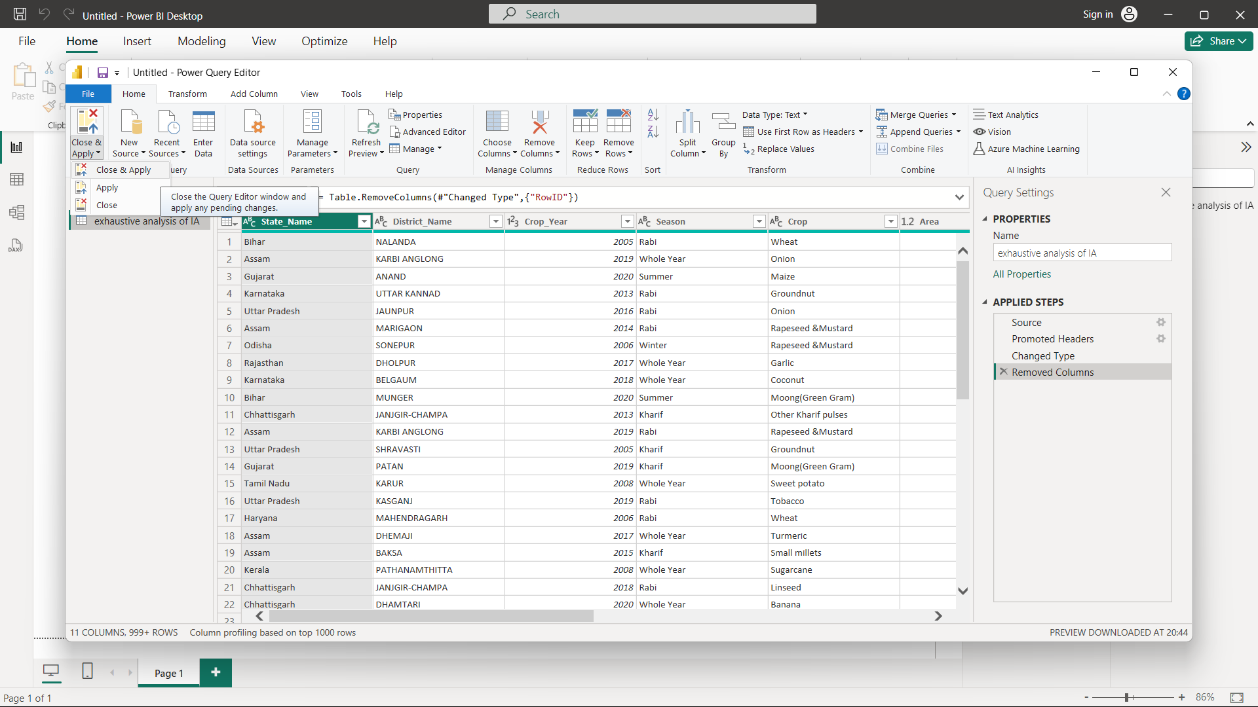

In order to save any changes made click on Close and Apply icon, this saves the file and returns with ant chnages made.